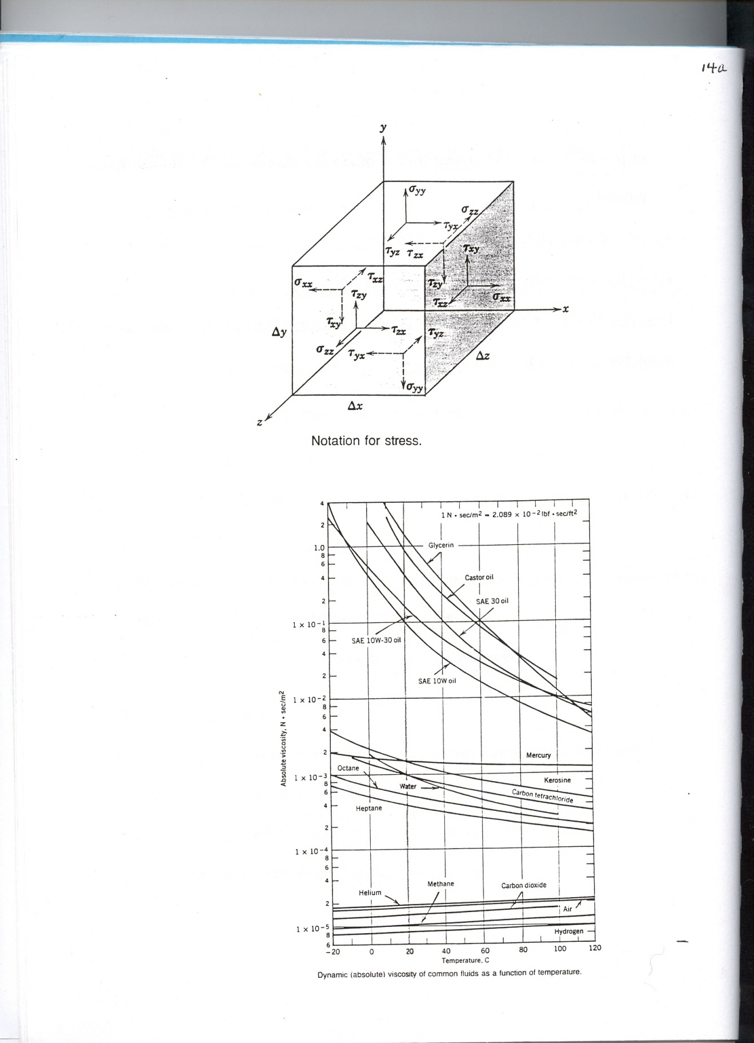

**Notation for Positive Stresses and Variation of Viscosity with Temperature** – For fluids, viscosity decreases with temperature because bond strength decreases making molecules more mobile and decreasing viscosity; for gases, molecules gain energy increasing collisions and increasing viscosity.